Assignment - 2

Kartik Velede

8672807

Data Flow – INFO8910

Doug Ferrier

July-23-2020

July-29-2020

**Table of Contents**

**Business Case 3**

**Forms 4**

**Salon Appointment Booking Form: 4**

**Salon Appointment Booking Form Settings 6**

**Salon Feedback Form 8**

**Salon Feedback Form Settings 10**

**Forms Responses 11**

**Appointment Booking Form Response 11**

**Feedback Form Responses 12**

**Microsoft Flows 13**

**Email Notification 15**

# Business Case

Organization with the help of HR manager has introduced several new perks to enable workers to work longer hours which includes on-site dry cleaning, dog walking and a beauty salon for staff only.

The salon has become extremely successful and HR has asked to develop a form to book salon appointment with the hairdressers to streamline the hair appointment booking process. This form is available only to workers in the company and the owner of the forms must be informed by email when response is submitted

By taking into consideration of various tools Microsoft form is the best fit tool for creating forms for appointment booking and taking feedback. To get email notification when a new response has been submitted, we will be using Microsoft Flows one for salon appointment and other for feedback.

This document consists of step by step process of creating forms for booking appointment, taking feedback and how the owner is being notified about the new submitted response.

# Forms

## **Salon Appointment Booking Form:**

The following link can be used to fill the form for booking an appointment with salon

<https://forms.office.com/Pages/ResponsePage.aspx?id=OjndTYrpBESEH8S-zdklpSC3-6VD9-5JtqwkuJFenCpUMTQzODZDSkFVWUg2MUtYT0oySjRJN1RaRS4u>

Below are the screenshots taken while creating a Microsoft Form for scheduling a salon appointment .

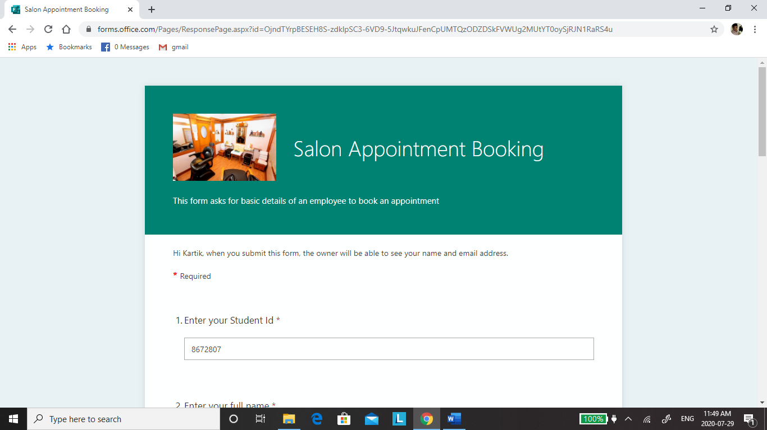

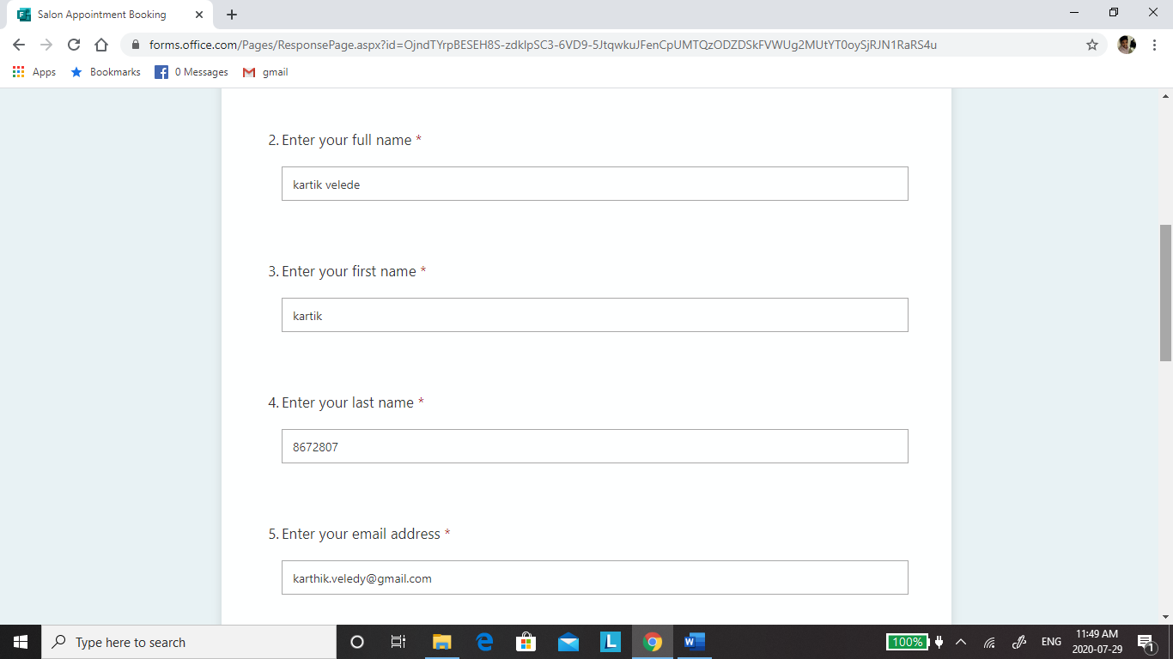

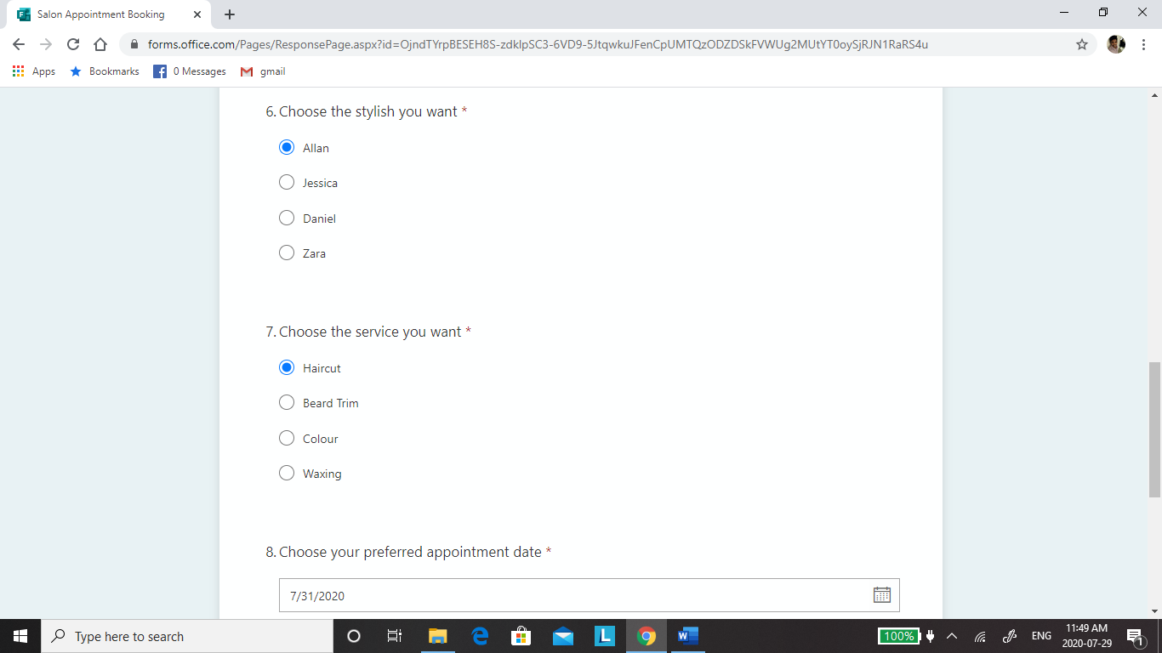

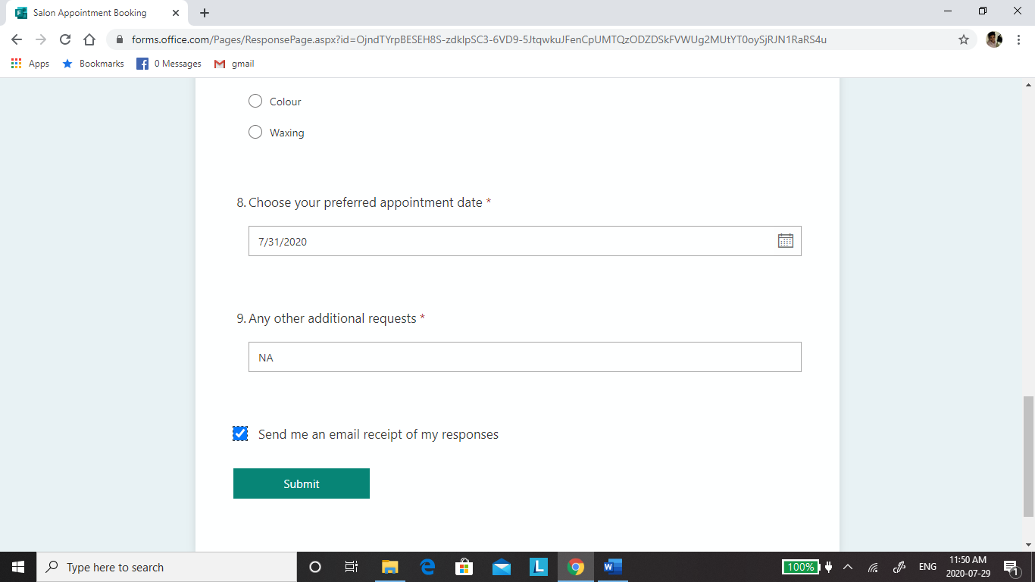

## **Salon Appointment Booking Form Settings**

Below screenshots show the setting that are enabled for the appointment booking form.

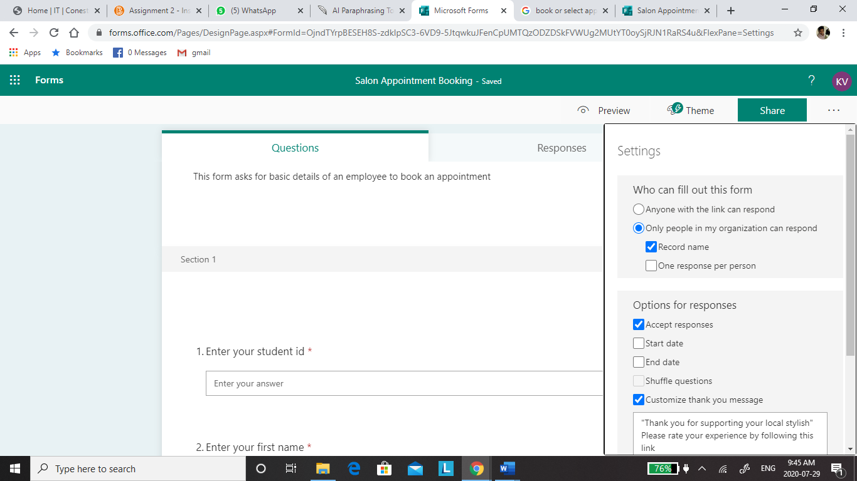

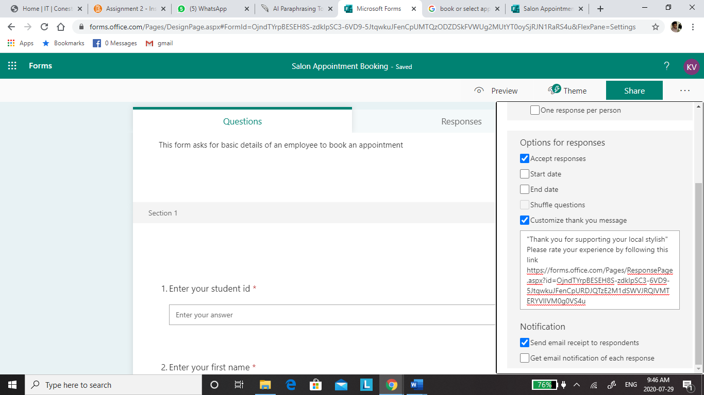

Once the customer submits this form a thank you message will be displayed with a link which redirects to feedback form where customer is asked few questions about the service provided by salon.

## **Salon Feedback Form**

The following link can be used to fill the feedback form for the service provided by the salon.

<https://forms.office.com/Pages/ResponsePage.aspx?id=OjndTYrpBESEH8S-zdklpSC3-6VD9-5JtqwkuJFenCpURDJQTzE2M1dSWVJRQlVMTERYVllVM0g0VS4u>

Below are the screenshots taken while creating a Microsoft Form for collecting feedback from customers.

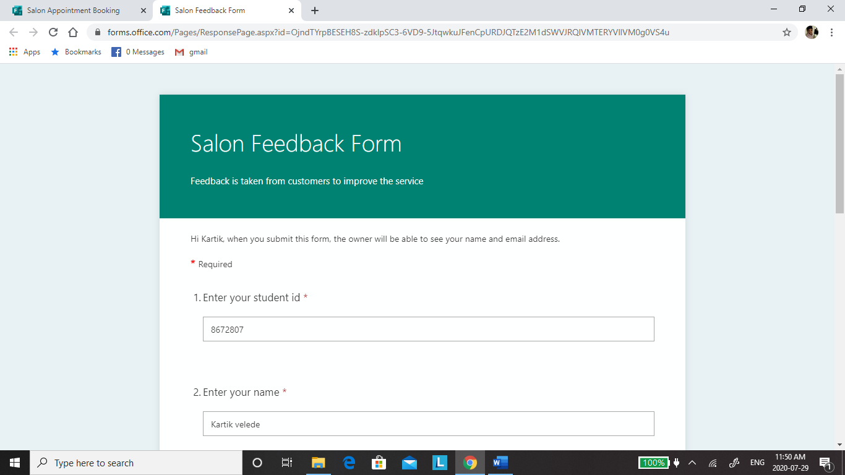

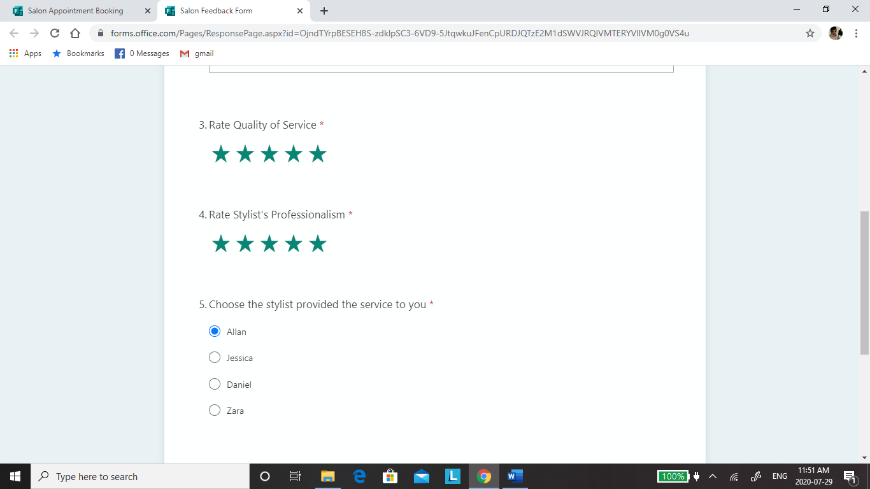

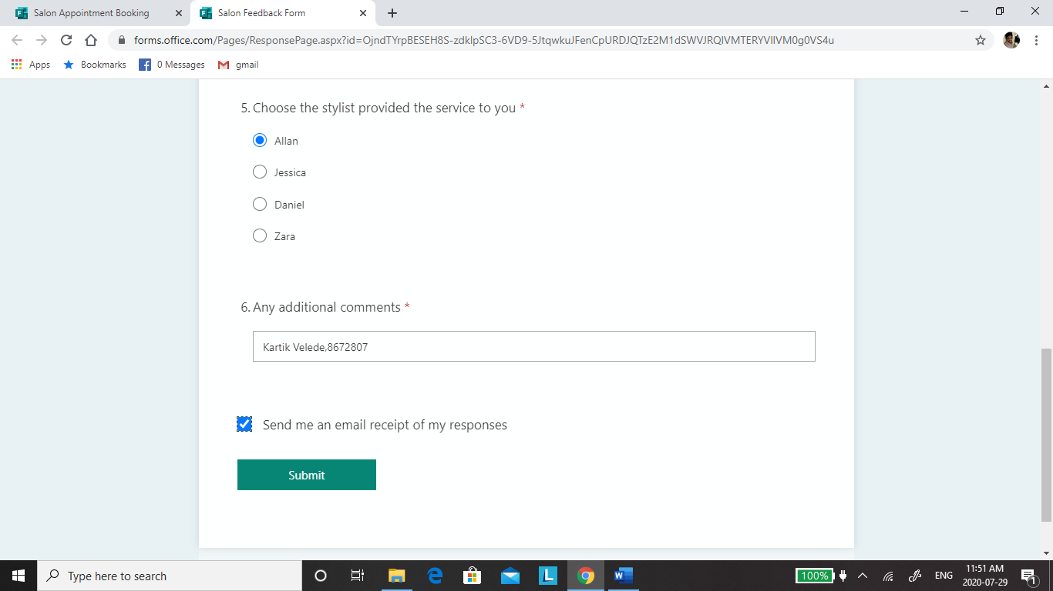

## **Salon Feedback Form Settings**

Below screenshots show the setting that are enabled for the feedback form.

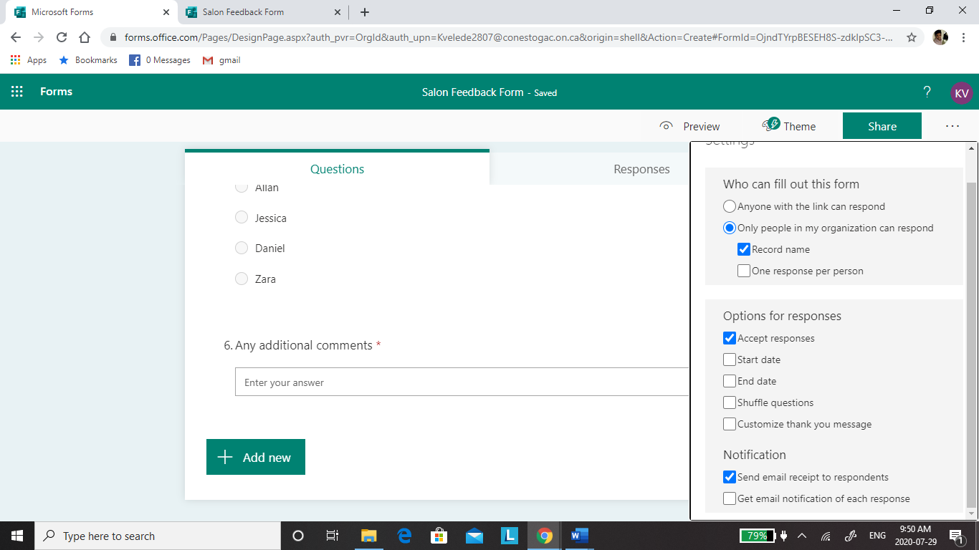

# Forms Responses

## **Appointment Booking Form Response**

All the responses received from the customer for booking an appointment is exported to excel sheet as shown in below screenshot.

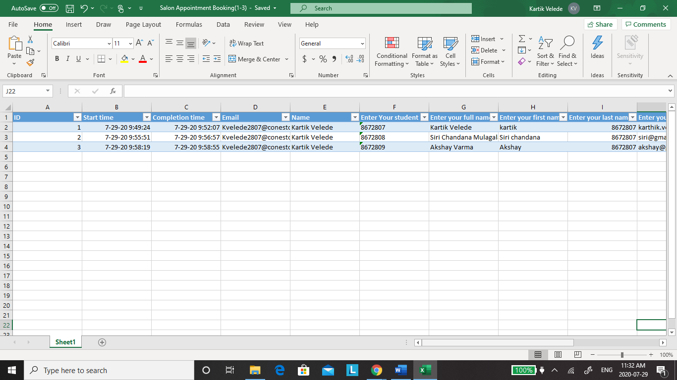

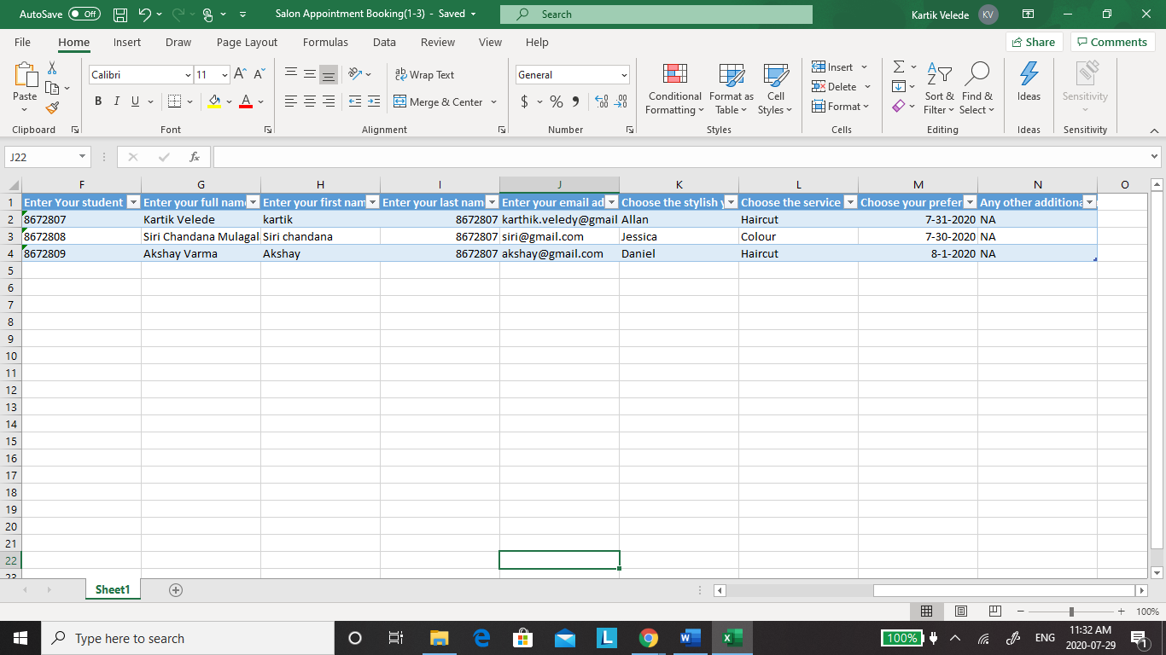

## **Feedback Form Responses**

All the feedback received from the customer is exported to excel sheet as shown in below screenshot.

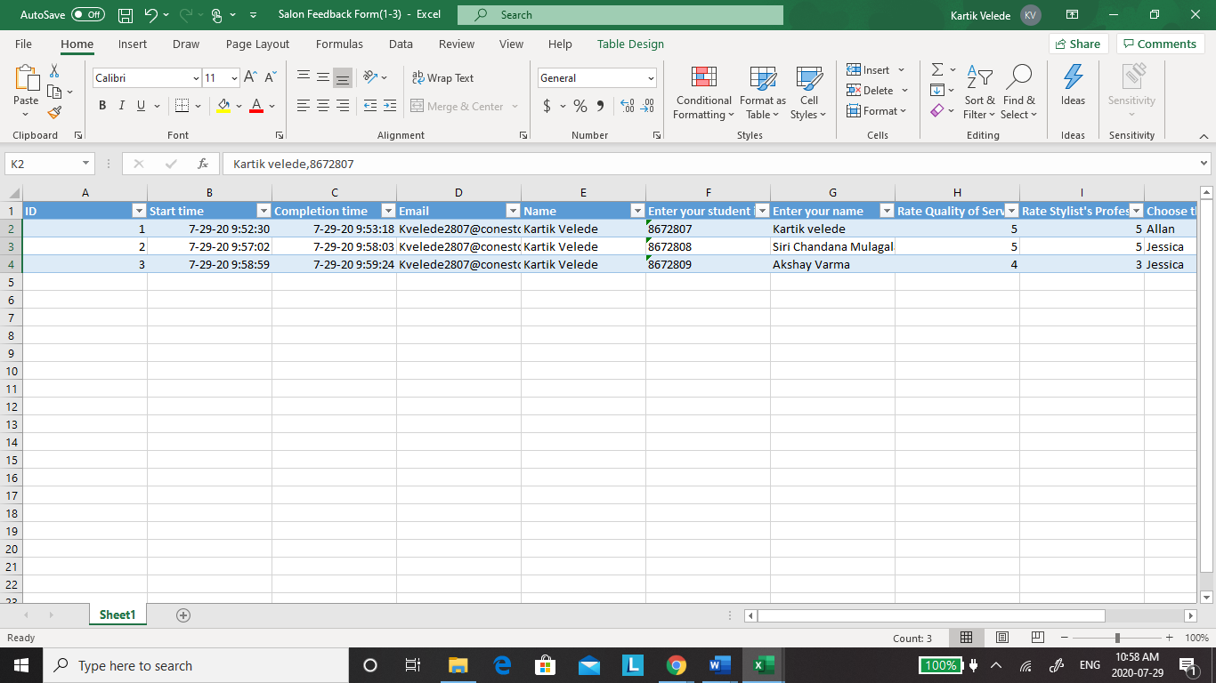

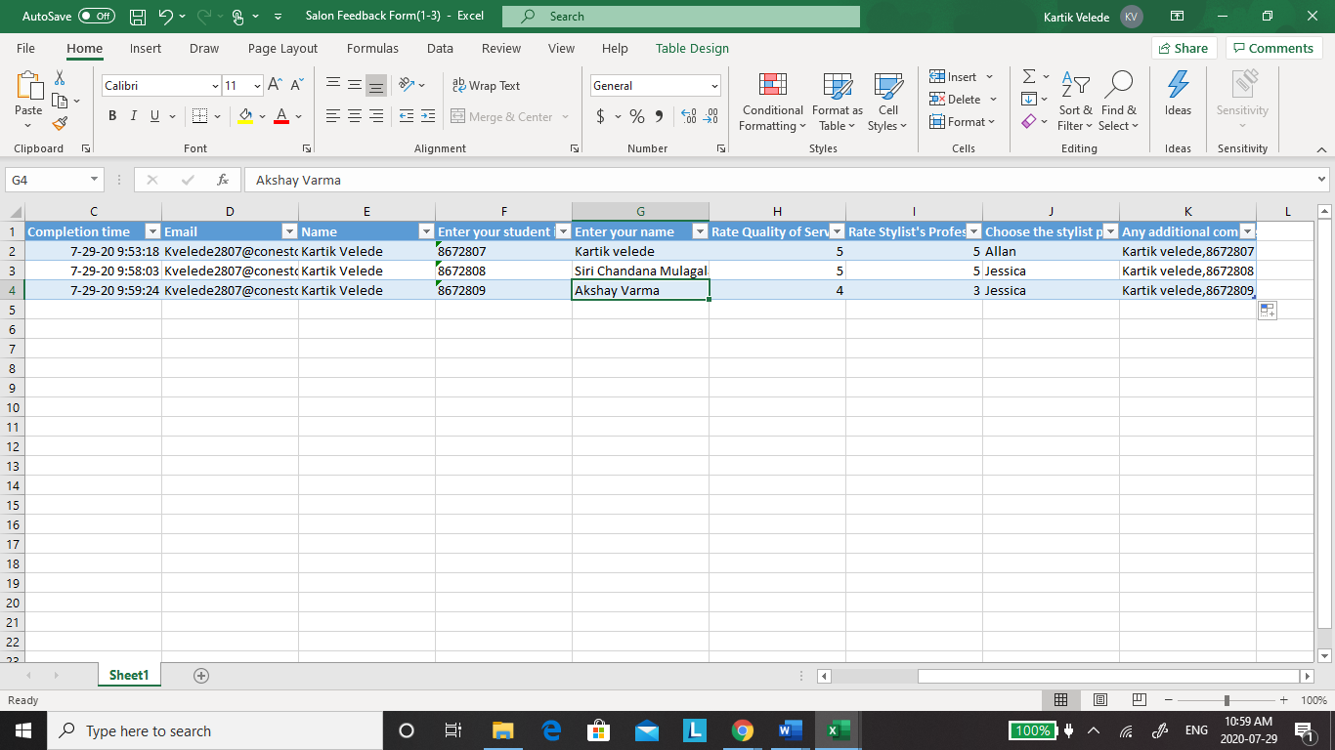

# Microsoft Flows

Power automate tool is used to send an email to responder when response submitted in Microsoft Forms

Below figure show the flow of Salon Appointment booking.

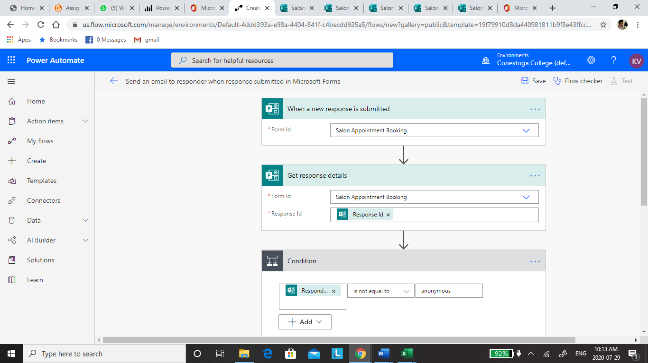

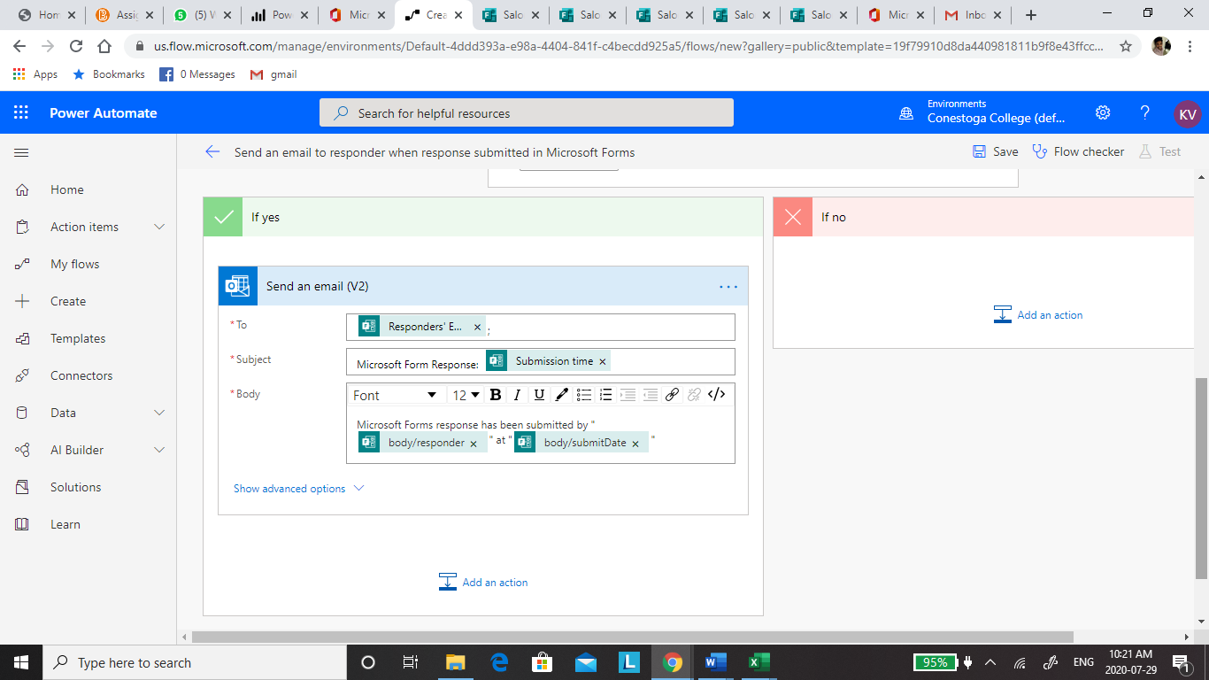

Below figure show the flow of Salon Feedback

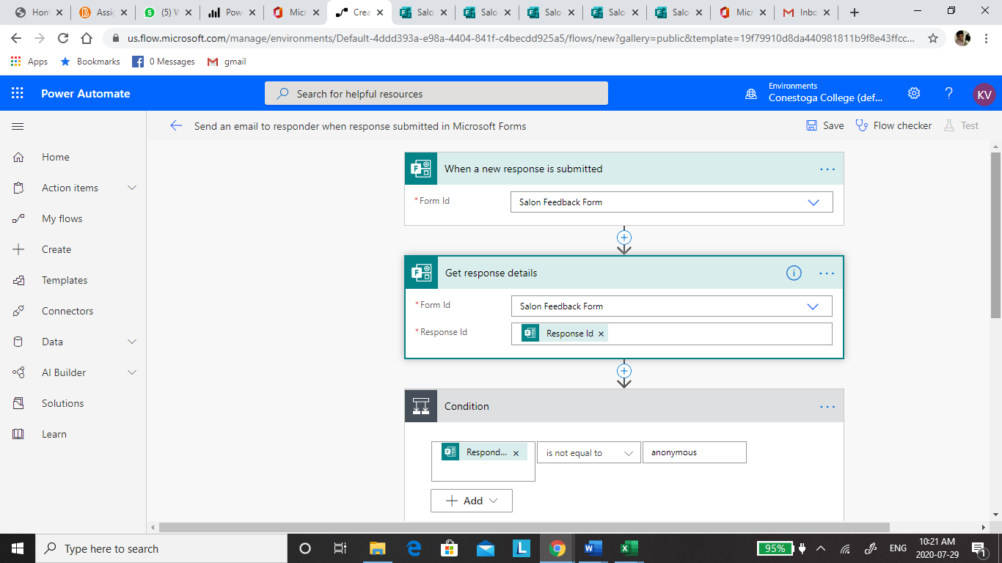

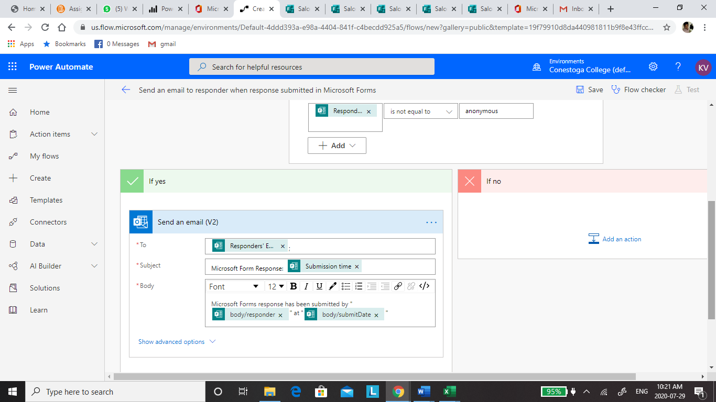

# Email Notification

Received email notification when a response is submitted from Appointment Booking Form

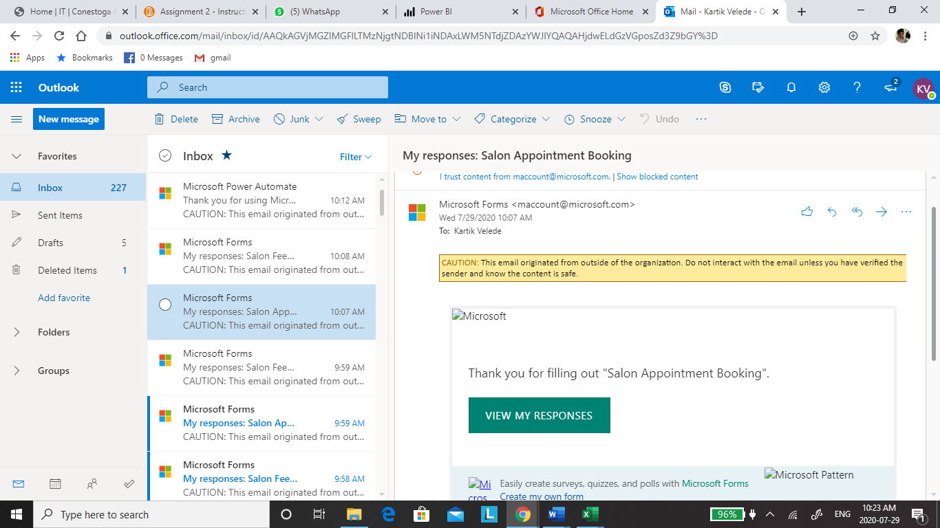

Received Email Notification when feedback from is submitted by customer.

